Soldering Order

1. Bottom Layer
   1. FT232RL
   2. MSGEQ7 2pc
   3. 5v Reg
   4. 220 ohm Resistors 5pc (solder them consecutively to insure even spacing)
   5. 0.1 uF Capacitors 5pc
   6. 200k Ohm Resistors 2pc
   7. 33pF Capacitors 2pc
   8. 1nF Capacitors 2pc (make sure solder joints are smooth)
   9. WS2812B (it’s the box component in the middle, make sure the component is rotated correctly to ensure that the tap on the component aligns with the tab on the board)
   10. 9 Contact dipswitch
2. Top Layer
   1. ATMEGA328P
   2. WS2812B (it’s the box component in the middle, make sure the component is rotated correctly to ensure that the tap on the component aligns with the tab on the board.
   3. 220 ohm Resistors 5pc (solder them consecutively to insure even spacing)
   4. 1k Resistor
   5. Led (Orientation Matters! There is a green side on the LED if you don’t see it look on top and tilt the LED a bit, this green side goes to the lined side on the board 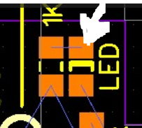
   6. 10k Resistor 1pc
   7. 0.1 uF Capacitors 4pc (100nF and 0.1uF are the same component)
   8. 1M Resistor 1pc
   9. 22 pF Resistor 2pc
   10. 10 uF Capacitors 3pc
   11. 10nf Capacitor 1pc
3. Clean the Board with solution make sure no flux remains
4. Solder the 6pin ICSP connector  
    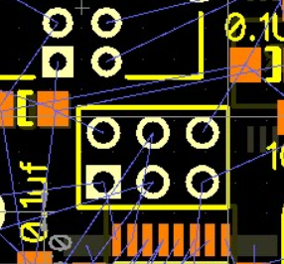
5. Solder in the crystal 16 Mhz   
   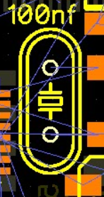
6. Snap in the RJ10 and USB Connectors and solder them
7. Do not solder the Potentiometer or the Audio Jack until the board has been tested and placed into the enclosure.